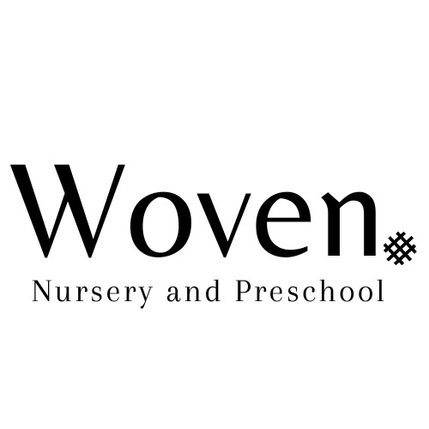

**Care, Learning & Play Policy**

**Date of last update: March 2024**

**Date of next review: March 2025**

We will do our best to meet the individual needs of the children in our care and promote their welfare.

We will plan and provide activities appropriate to each child’s individual needs. We will talk to, listen to and play with the children in our care.

We will provide activities that support all the areas of learning and development in accordance with the Montessori principles and the EYFS:

Literacy, mathematics, communication, and language, physical, understanding of the world, expressive art and design, personal, social, and emotional development.

We will make regular observations of your child’s progress and development using Tapestry (please see Tapestry policy); we will keep a written record which will help us to assess your child’s development and move him/her onto the next stage.

Records are available for you to view at any time however must be kept onsite.

The activities, toys and learning resources available to each child will be age and ability appropriate.