

**Fire Prevention Policy and Fire Evacuation Procedure**

**Date updated: April 2024**

**Date of next review: April 2025**

## Fire Prevention

* We have access to a telephone.
* A fire blanket/fire bucket is located near the fire pit
* We have a fire evacuation plan.

## Fire Evacuation

The following Fire Evacuation plan will be followed in the event of a fire:



* At first warning, the fire alarm will sound to alert everyone.
* We will stop what we are doing and walk to the bottom gate.
* A member of management will take the tablet and Mobile phone which has attendance record and contact numbers. The fire marshal will sweep the nursery and the outdoor areas for any children and collect the help bag.
* We will leave by the back door in the nursery and meet in the evacuation point located in the back garden/forest school.
* Immediately on evacuating the premises we will call the emergency services if required.
* We will wait at a safe distance from the preschool in the back garden.
* We will contact parents/guardians as soon as possible.
* We will comfort and reassure the children.
* We will follow the instruction of the Emergency Services and will not return to the Nursery until they have declared it to be safe to do so.





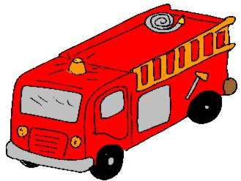

# On the sound of the fire alarm you will STOP what you are doing.

* + **Follow a member of staff and leave the nursery (DO NOT RUN)**
  + **Wait quietly at the assembly point in the back garden/allotment.**
  + **Listen for your name to be called.**
  + **We will then call the fire Brigade if necessary.**
  + **We will wait till it is safe to go back into the nursery before returning to our learning and play.**